**Statistics: The Science of Decisions Project Instructions**

**Thiravia Nandhan P**

**January 27, 2019**

**Background Information:**

In a Stroop task, participants are presented with a list of words, with each word displayed in a color of ink. The participant’s task is to say out loud the color of the ink in which the word is printed. The task has two conditions: a congruent words condition, and an incongruent words condition. In the congruent words condition, the words being displayed are color words whose names match the colors in which they are printed: for example, RED, BLUE. In the incongruent words condition, the words displayed are color words whose names do not match the colors in which they are printed: for example, PURPLE, ORANGE. In each case, we measure the time it takes to name the ink colors in equally-sized lists. Each participant will go through and record a time from each condition.

**Questions for Investigation:**

1. **What is our independent variable? What is our dependent variable?**
   1. **Independent Variable**: The independent variable is the font color / word.
   2. **Dependent Variable**: The dependent variable is the time taken to identify the Congruent or Incongruent words.
2. **What is an appropriate set of hypotheses for this task? What kind of statistical test do you expect to perform? Justify your choices.**

In here the same set of people were first tested for Congruent words and then the same set of people were tested for Incongruent words. As per the data sheets there is no mention of Population Mean / Standard Deviation, hence t-tests has to be performed, because z-tests are used when we have the Population Mean / Standard Deviation information provided.

**Note: This problem looks exactly similar to Lesson 26: L10a-t-tests Part 1: Quiz- Keyboard**

**Hypothesis:**

Going with the t-tests, following is my hypothesis.

1. **H0 (Null Hypothesis)**: Time taken to identify Congruent or Incongruent words would be approximately equal.

**μI = μC**

1. **Ha (Alternative Hypothesis)**: Time taken to identify Incongruent words would be not equal to time taken to identify the Congruent words.

**μI ≠ μC**

Our goal is the prove the Alternative Hypothesis.

**Symbol Description:**

**μC**: Mean of Time taken to identify Congruent words

**μI**: Mean of Time taken to identify Incongruent words

**Statistical Test:**

Since my hypothesis mentions that the time taken to identify Incongruent words would be not equal to that of for Congruent words, it would be a

1) both-directional

2) two-tailed

3) Dependent t-test

because same set of people are undergoing 2 conditions and we are un-aware of the Population parameters such as Population Mean and Standard Deviation, which otherwise would be a Z- test.

1. **Report some descriptive statistics regarding this dataset. Include at least one measure of central tendency and at least one measure of variability.**
   1. Congruent Values:
      1. Mean: 14.051125
      2. Median: 14.3565
   2. Incongruent Values:
      1. Mean: 22.01591667
      2. Median: 21.0175
   3. Other calculations are presented below in Q #5.
2. **Provide one or two visualizations that show the distribution of the sample data. Write one or two sentences noting what you observe about the plot or plots.**
   1. 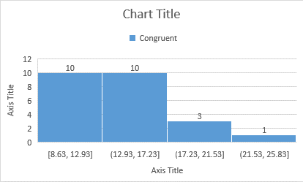Below is the Histogram for Congruent data. The Histogram looks to be a Positively Skewed distribution, with maximum people identifying Congruent words in faster time.
   2. 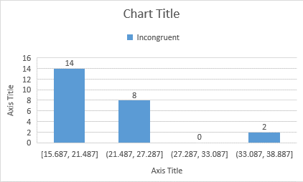Below is the Histogram for Incongruent data. The Histogram also looks to be a Positively Skewed distribution, with maximum people identifying Incongruent words in faster time.
   3. Below is the Histogram for Difference between Congruent and Incongruent time values. It is a negatively skewed distribution.

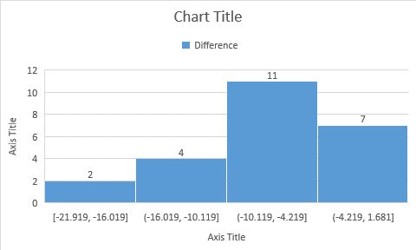

1. **Now, perform the statistical test and report your results. What is your confidence level and your critical statistic value? Do you reject the null hypothesis or fail to reject it? Come to a conclusion in terms of the experiment task. Did the results match up with your expectations?**

**Statistical Test:**

|  |  |  |  |
| --- | --- | --- | --- |
| **Congruent** | **Incongruent** | **Difference=**  **Congruent - Incongruent** | **Squared Deviation From Mean** |
| 12.079 | 19.278 | -7.199 | 0.586436877 |
| 16.791 | 18.741 | -1.95 | 36.17771879 |
| 9.564 | 21.214 | -11.65 | 13.58076046 |
| 8.63 | 15.687 | -7.057 | 0.82408571 |
| 14.669 | 22.803 | -8.134 | 0.02863146 |
| 12.238 | 20.878 | -8.64 | 0.455906293 |
| 14.692 | 24.572 | -9.88 | 3.66802296 |
| 8.987 | 17.394 | -8.407 | 0.19554821 |
| 9.401 | 20.762 | -11.361 | 11.53423104 |
| 14.48 | 26.282 | -11.802 | 14.72416779 |
| 22.328 | 24.524 | -2.196 | 33.27895729 |
| 15.298 | 18.644 | -3.346 | 21.33323646 |
| 15.073 | 17.51 | -2.437 | 30.55648071 |
| 16.929 | 20.33 | -3.401 | 20.82819438 |
| 18.2 | 35.255 | -17.055 | 82.63188754 |
| 12.13 | 22.158 | -10.028 | 4.256828627 |
| 18.495 | 25.139 | -6.644 | 1.744490627 |
| 10.639 | 20.429 | -9.79 | 3.33138546 |
| 11.344 | 17.425 | -6.081 | 3.548671043 |
| 12.369 | 34.288 | -21.919 | 194.7199302 |
| 12.944 | 23.894 | -10.95 | 8.911468793 |
| 14.233 | 17.96 | -3.727 | 17.95887821 |
| 19.71 | 22.058 | -2.348 | 31.54834863 |
| 16.004 | 21.157 | -5.153 | 7.906172377 |

**Descriptive Statistics:**

|  |  |
| --- | --- |
| **Mean** | -7.964791667 |
| **Variance** | 23.66654087 |
| **Standard Deviation** | 4.86482691 |
| **Standard Error** | 0.993028635 |
| **tstatistics** | -8.020706944 |

**Other Calculations:**

1. **Confidence Level:**
   1. 95 %
   2. **α = 0.05**
   3. **tcritical = 2.069**
2. **tstatistics** is beyond the **tcritical** hence we **Reject the (H0) Null Hypothesis.**
3. Effect Size Measure:
   1. **Cohen’s d**: -1.637219949
   2. The P-Value is < .00001.
4. Confidence Interval of 95% is as below:
   1. **CI:** -10.01936791 to -5.910215421
   2. This means people identify Congruent words faster than Incongruent words.
5. **Optional: What do you think is responsible for the effects observed? Can you think of an alternative or similar task that would result in a similar effect? Some research about the problem will be helpful for thinking about these two questions!**

Practice makes a man perfect.

If every person practices identifying Incongruent words, then definitely the person would take same or even lesser time to identify the Incongruent words. It is just a matter of Practice and nothing else.

A person in his daily life come across a lot of words, but when it comes to color he come across a very little time and that too with a word that mentions a color but written with a different font color.

This effect can be reversed or equaled if we identify a population sample who have been trained to identify Incongruent words.

1. **Reference Section**
   * 1. <https://en.wikipedia.org/wiki/Stroop_effect>
     2. <https://keydifferences.com/difference-between-t-test-and-z-test.html>
     3. <https://www.socscistatistics.com/pvalues/tdistribution.aspx>
     4. <http://statisticsbyjim.com/basics/measures-central-tendency-mean-median-mode/>
     5. <https://study.com/academy/lesson/z-test-t-test-similarities-differences.html>